La Belle Bakery — Static Website Hosting on AWS S3
Author: Olabisi Lawal

Table of Contents

Lab 1 — Hosting a Static Website on AWS S3

Part 1 — Description
Host a static website for La Belle Bakery using Amazon S3 as the origin. The goal is to create a publicly accessible static site that serves HTML, CSS, images, and other static assets from an S3 bucket configured for static website hosting. Tools and AWS features used: AWS S3, AWS CLI (optional), CloudFront/Route 53 (optional), local development files (index.html, styles.css, images).

Part 2 — Preparation
- Created local site files: index.html; about.html; menu.html; styles.css; logo.png; hero.jpg; product photos.
- Installed and configured AWS CLI with credentials and default region.
- Reviewed AWS S3 static website hosting documentation and course lab instructions.
- Confirmed billing alerts and used an IAM user with S3 permissions for the lab.
- Prepared screenshot plan: bucket configuration; bucket policy; uploaded files list; public website URL.

Part 3 — Observations
1. Created S3 bucket named 'labellebakery' in region us-east-1.
2. Uploaded index.html, about.html, menu.html, styles.css, and images to the bucket.
3. Enabled static website hosting with index document set to index.html and error document to error.html.
4. Set bucket policy to allow public read access and adjusted Block Public Access settings.
5. Tested the public S3 website endpoint and verified homepage loaded correctly.
6. Optionally created a CloudFront distribution for HTTPS and custom domain support.
Troubleshooting:
- AccessDenied error due to misconfigured bucket policy and Block Public Access settings — fixed by aligning both.
- CSS file served with incorrect Content-Type — resolved by setting metadata to text/css.
- CORS not required for this static site — no cross-origin requests used.

Part 4 — Screenshots
- Screenshot 1 — S3 Bucket List
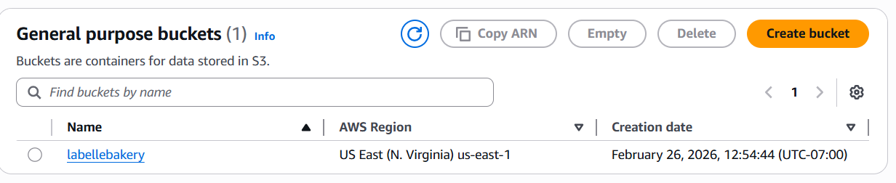
- Screenshot 2 — Static Website Hosting Enabled
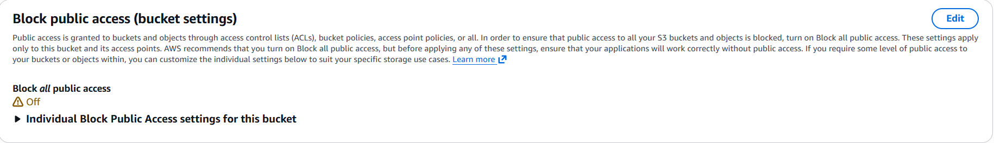
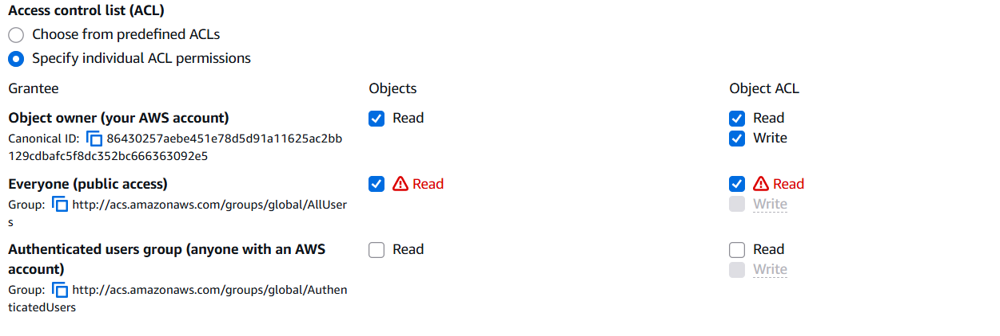
- Screenshot 3 — Bucket Policy
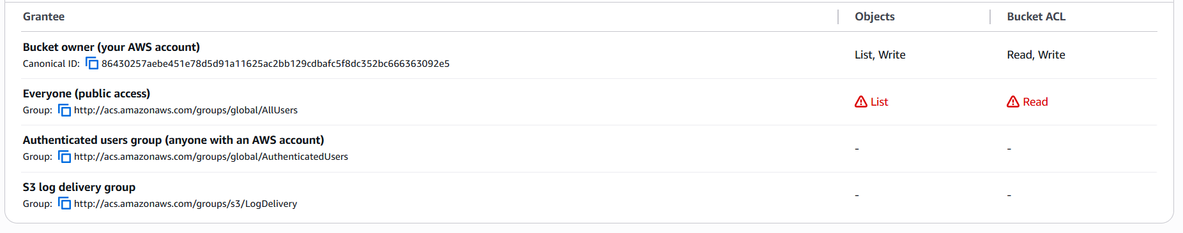
- Screenshot 4 — Public Website View
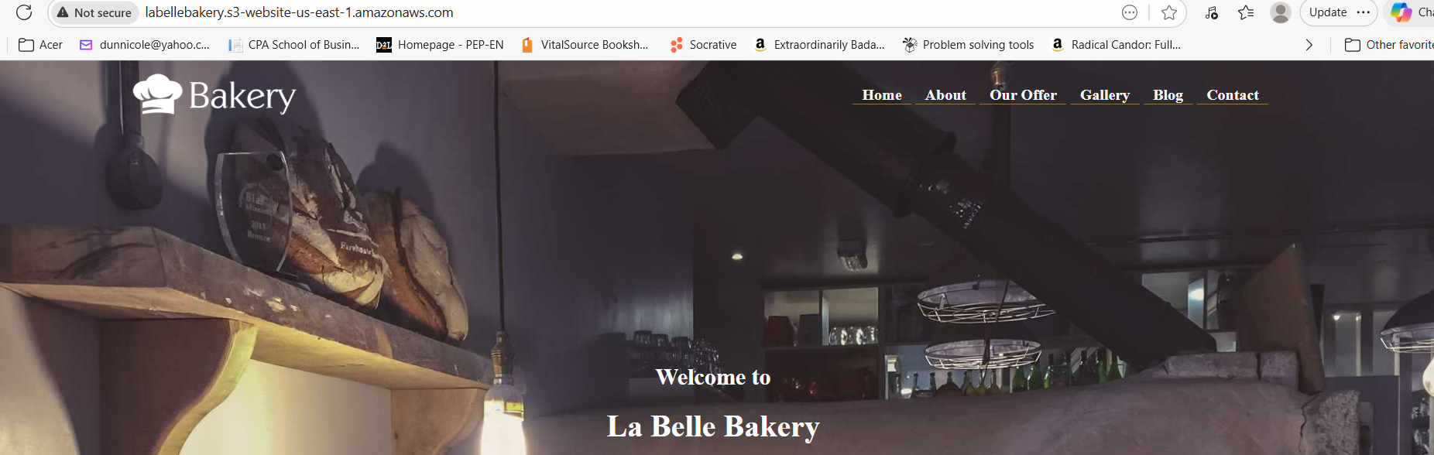
- Screenshot 5 — CloudFront Distribution
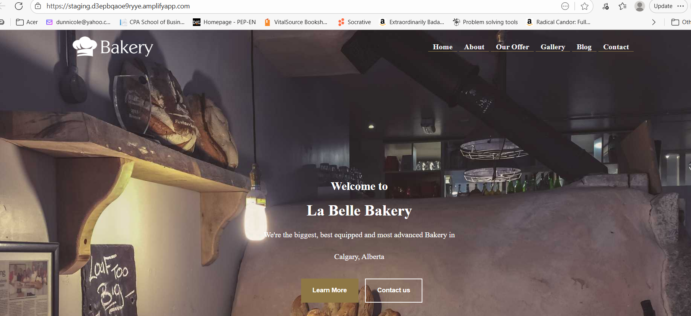

Part 5 — Reflection
Hosting La Belle Bakery on S3 reinforced the fundamentals of static website hosting, including bucket configuration, public access permissions, and metadata management. It also highlighted the importance of testing and troubleshooting permissions and content delivery settings.
For production use, additional considerations include cost monitoring, asset versioning, and HTTPS support. Key takeaway: Using S3 for static hosting is simple and cost-effective; pair S3 with CloudFront and ACM for production-ready HTTPS and performance.

References
AWS documentation: Amazon S3 static website hosting; S3 bucket policies; Amazon CloudFront and ACM.
Bakery website forked from https://github.com/OmarrSakr/Bakery-Website.git

